**Registry Editor:**

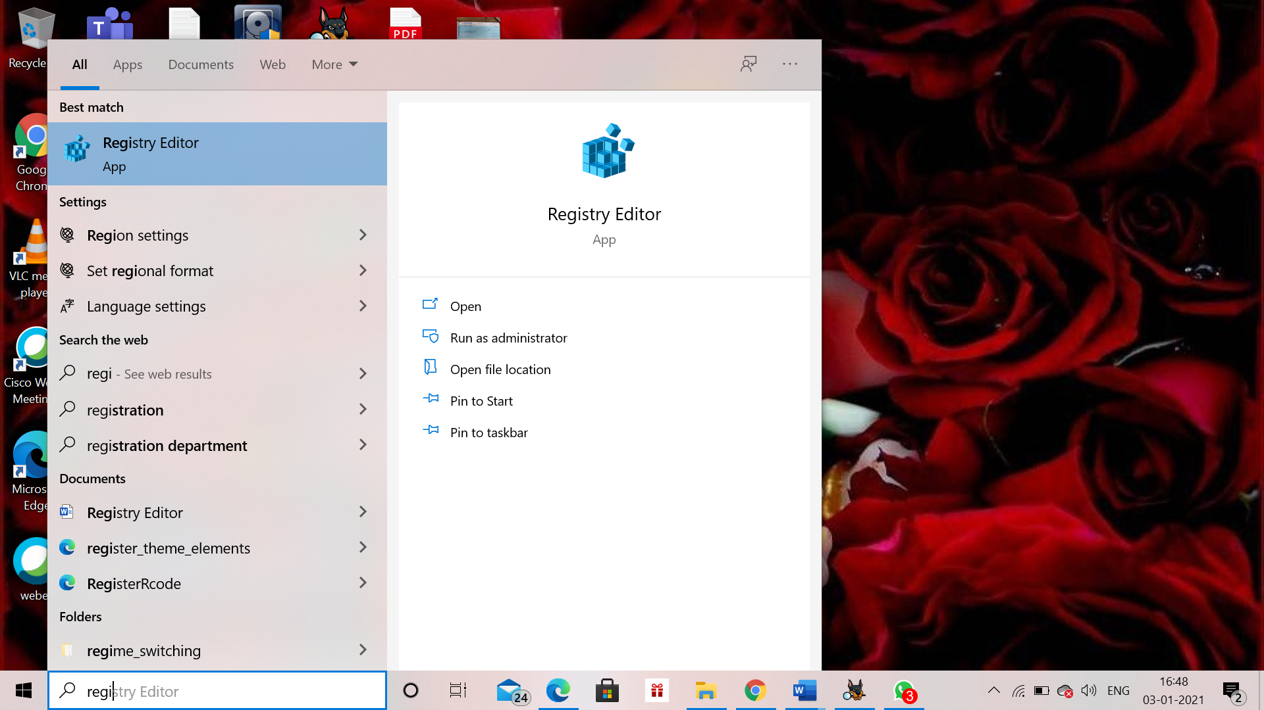

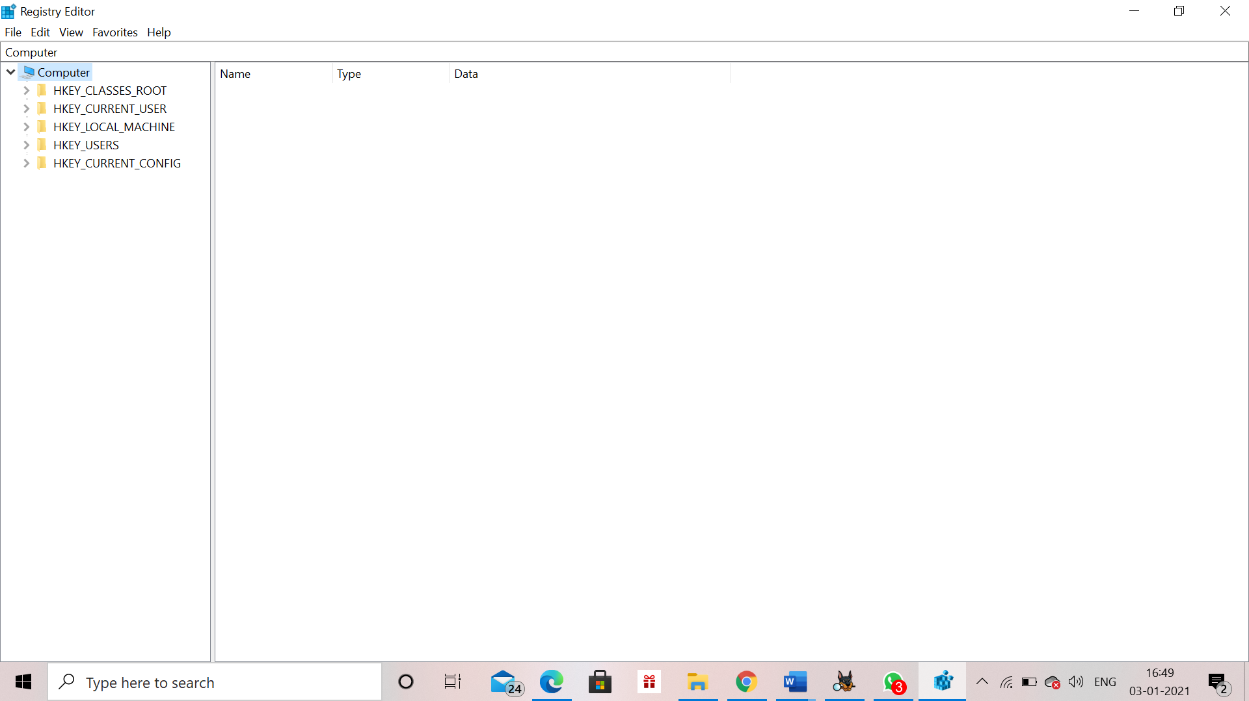

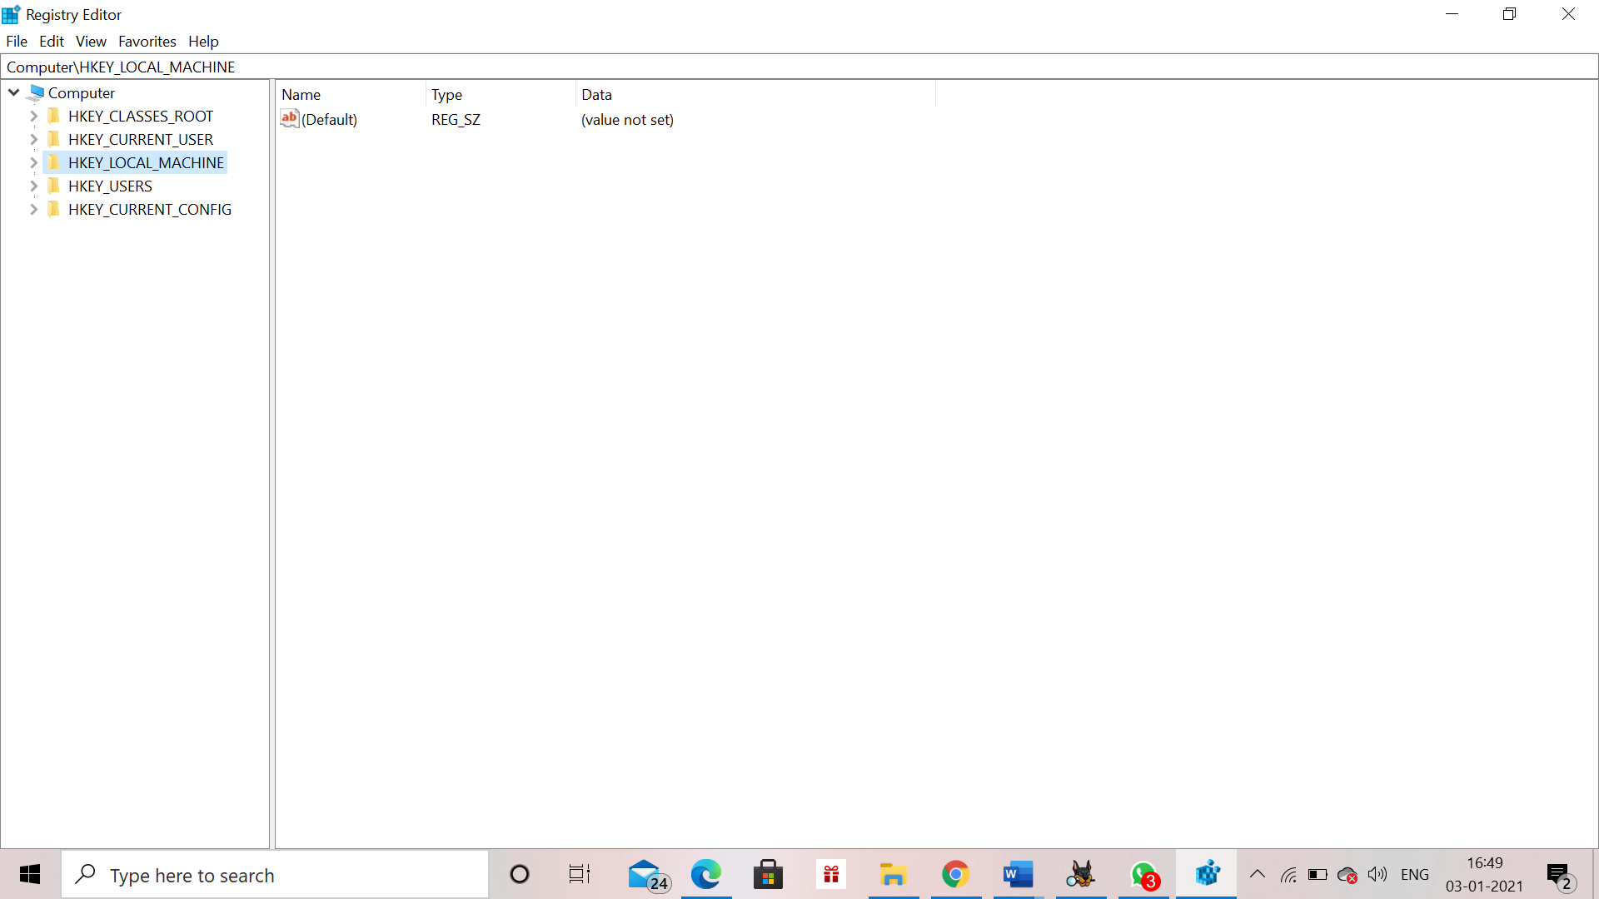

**Wireless Evidence in the Registry**

HKEY_LOCAL_MACHINE\SOFTWARE\Microsoft\WindowsNT\CurrentVersion\NetworkList\Profiles

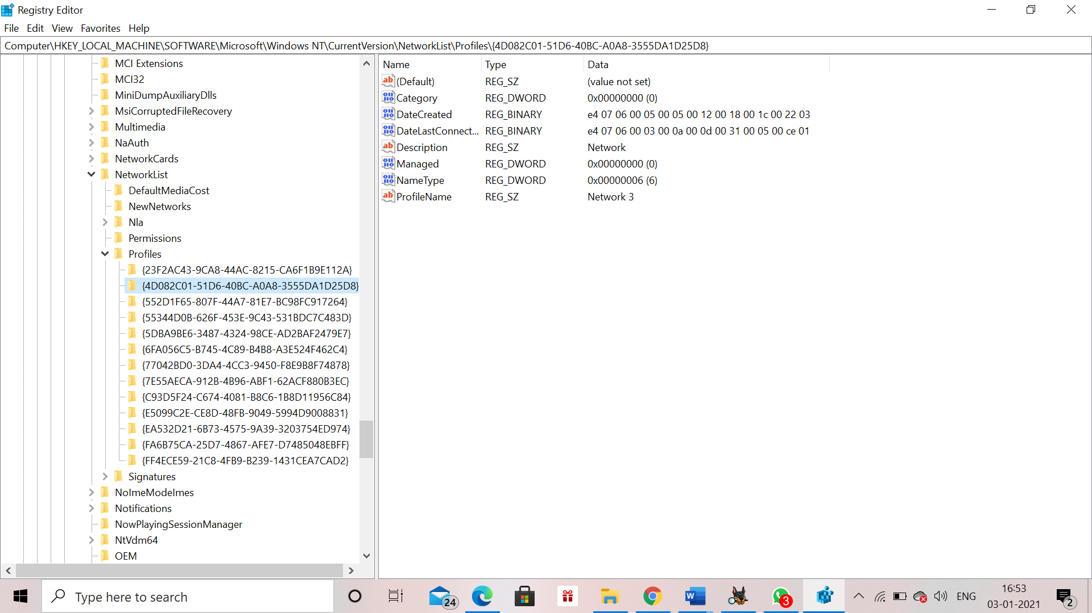

**The RecentDocs Key**

**HKEY_CURRENT_USER\Software\Microsoft\Windows\CurrentVersion\Explorer\RecentDocs\.docx**

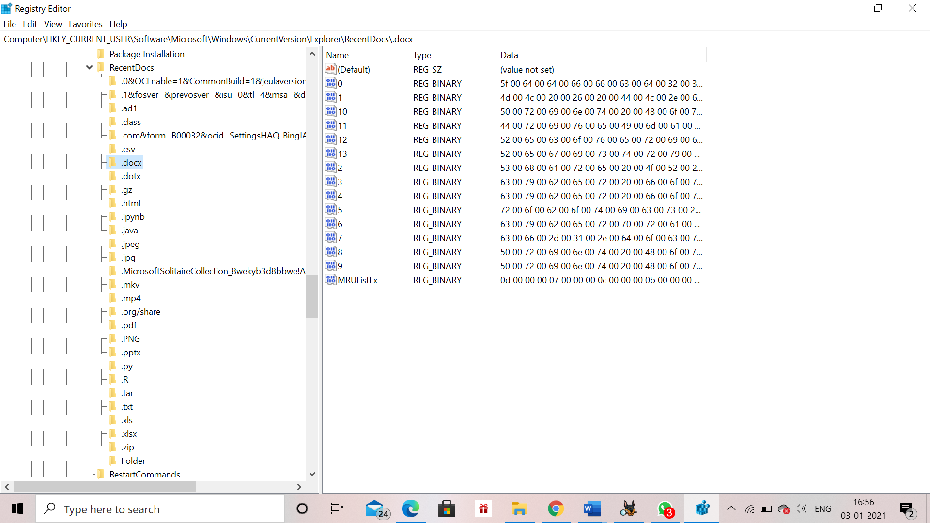

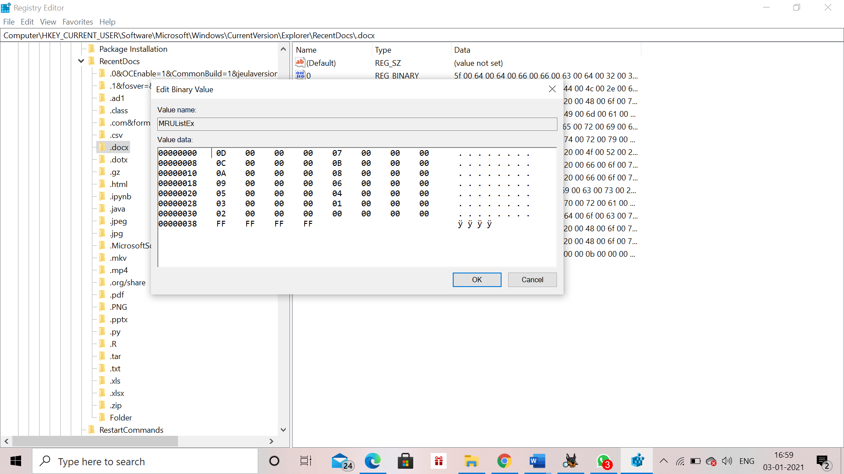

**TypedURLs Key**

**HKEY_CURRENT_USER\Software\Microsoft\Internet Explorer\TypedURLs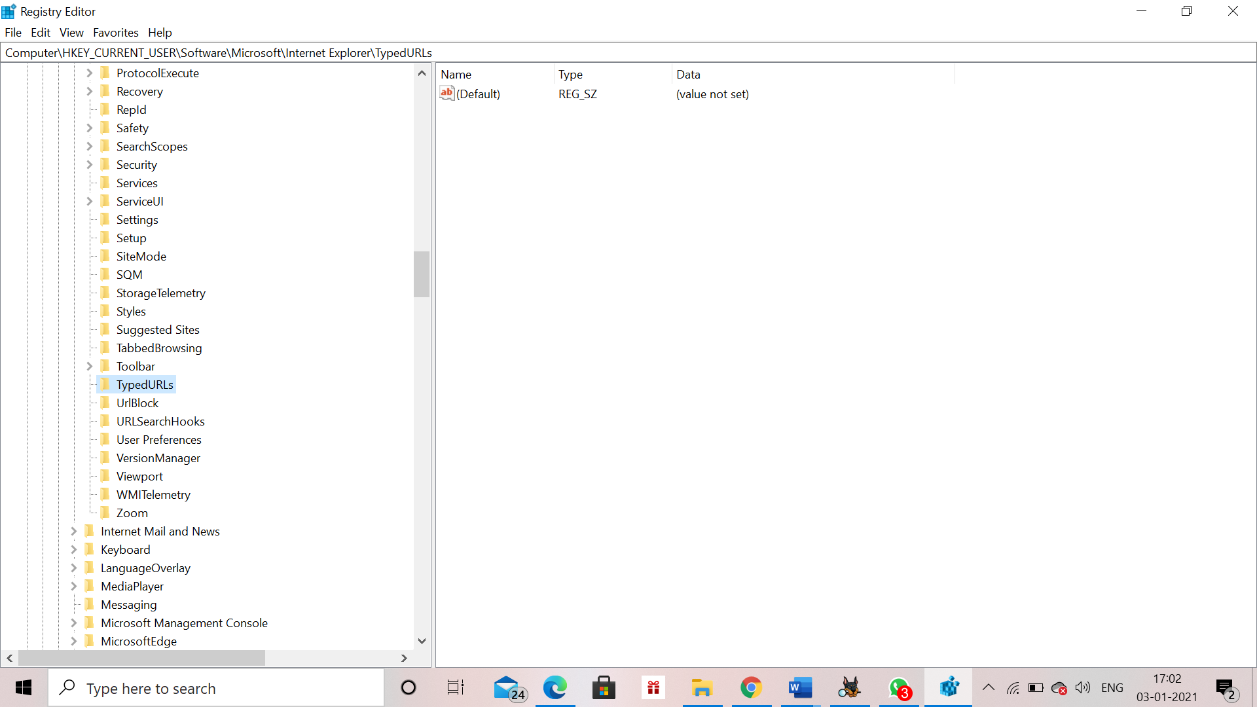IP Addresses**

**HKEY_LOCAL_MACHINE\System\CurrentControlSet\services\Tcpip\Parameters\Interfaces**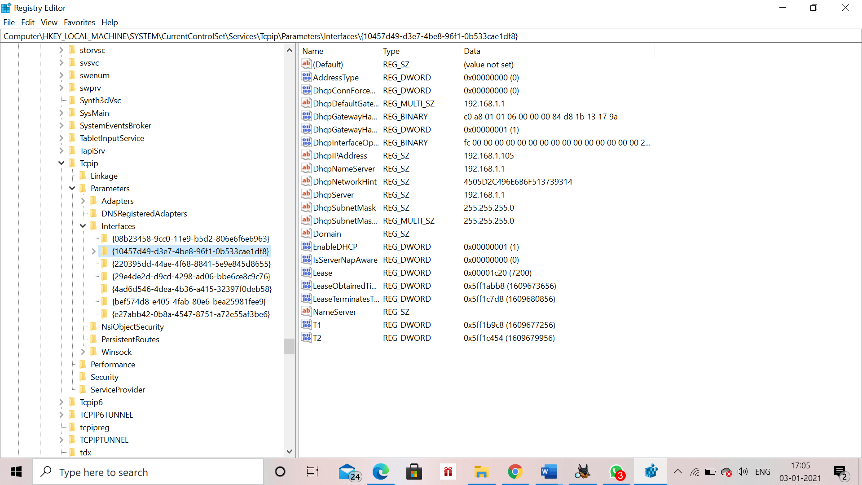

**Start Up Locations in the Registry**

**HKEY_LOCAL_MACHINE\Software\Microsoft\Windows\CurrentVersion\Run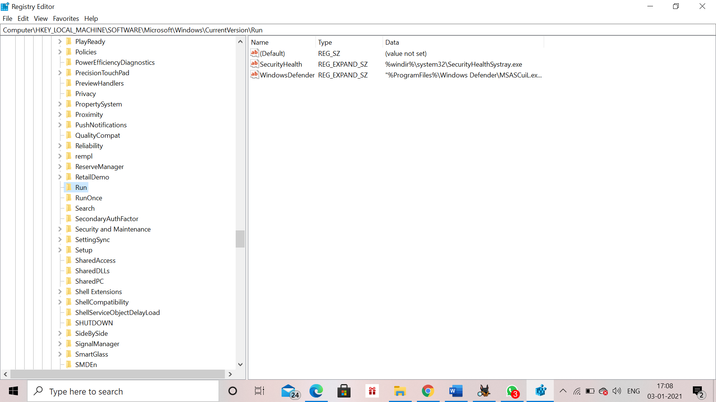RunOnce Startup**

**HKEY_LOCAL_MACHINE\Software\Microsoft\Windows\CurrentVersion\RunOnce**

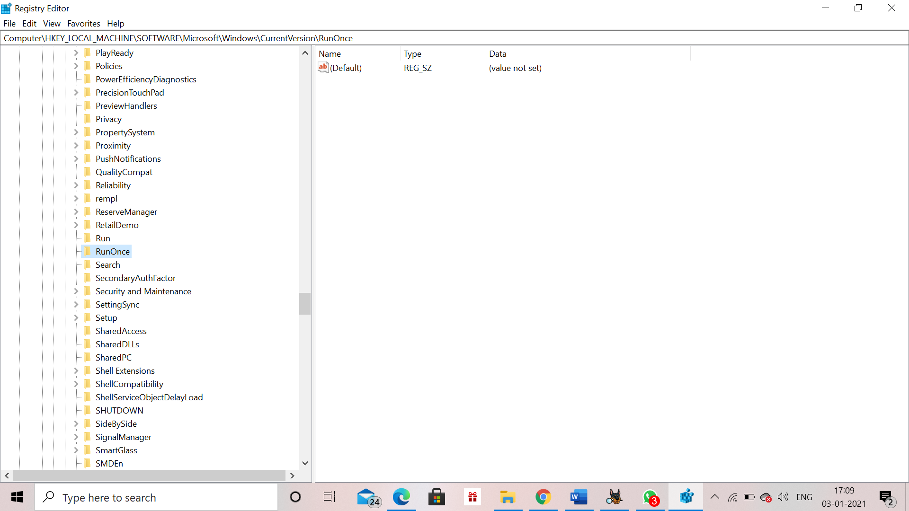

**Start Up Services**

**HKEY_LOCAL_MACHINE\System\CurrentControlSet\Services\1394ohci**

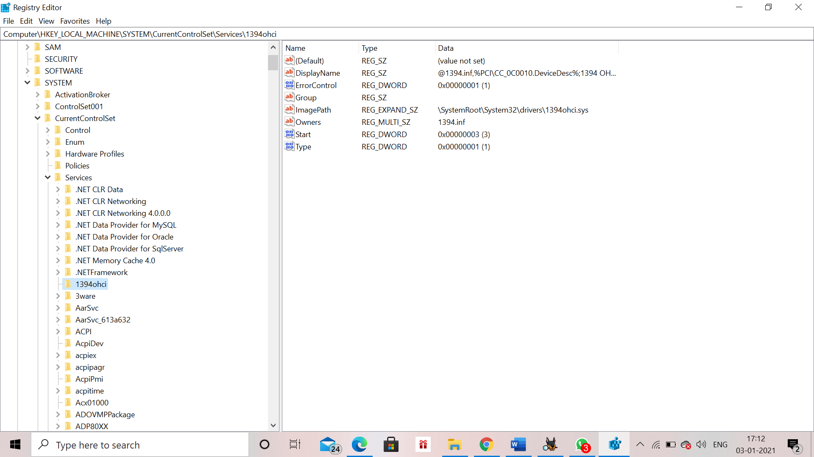**Start Legacy Applications**

**HKEY_LOCAL_MACHINE\System\CurrentControlSet\Control\WDI**

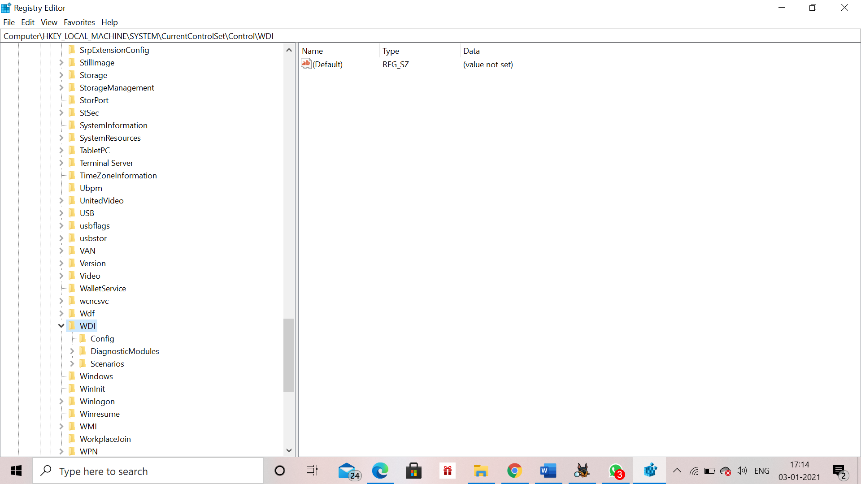

**Start When a Particular User Logs On**

**HKEY_CURRENT_USER\Software\Microsoft\Windows\CurrentVersion\Run**

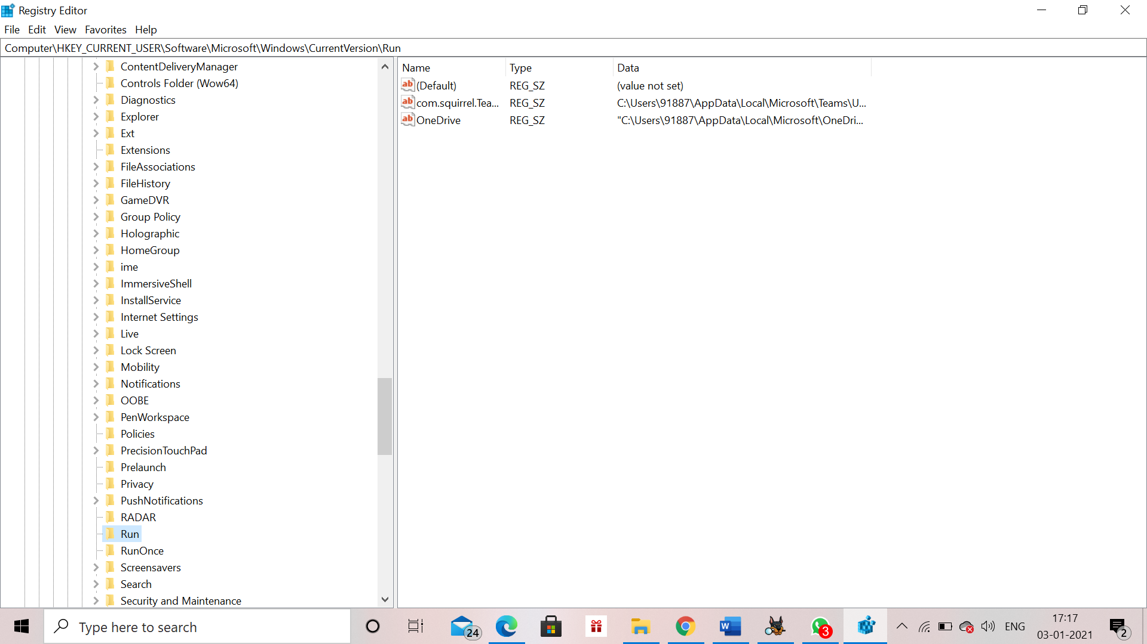**USB Storage Devices**

**HKEY_LOCAL_MACHINE\System\ControlSet001\Enum\USB**

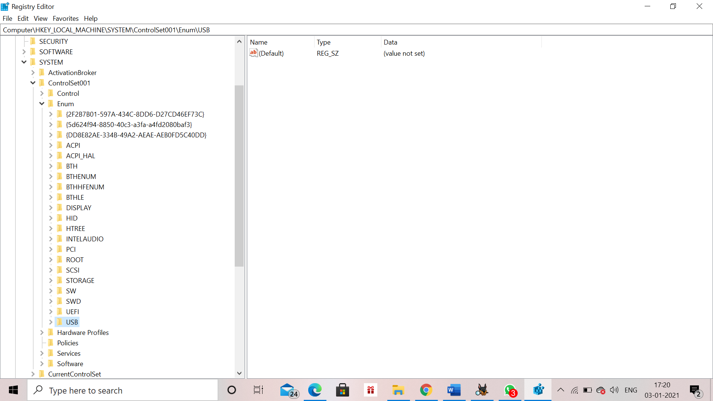

**Mounted Devices**

**HKEY_LOCAL_MACHINE\System\MountedDevices**

